Date

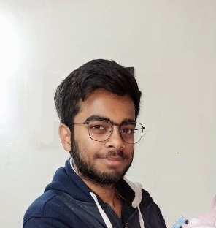

Ayushman Srivastava

Position Title

# Objective

To get started right away, just tap any placeholder text (such as this) and start typing to replace it with your own.

## Education

### SCHOOL NAME, LOCATION, DEGREE

You might want to include your GPA here and a brief summary of relevant coursework, awards, and honors.

## Vitals

Street Address  
City, ST ZIP Code

**T** Telephone

**E** Email

Street Address

City, ST ZIP Code

Dear Hiring Manager:

I'm excited to be applying for the Java Developer position at Siemens. As someone who is highly focused and attentive to detail, I thrive on building quality systems that surpass end users' expectations. I'm thrilled at the opportunity to show off my technical expertise and leadership skills as part of River Tech's expert team.

During my previous role at Crane & Jenkins, I was charged with developing innovative solutions across a variety of software platforms. I was instrumental in developing mobile-ready expense tracking software for our fast-growing portfolio of real estate clients. In 2016, I led the development of a proprietary document management system and was responsible for the successful migration of all client content from our legacy system to the new platform.

I am also attentive to the need for continued process improvements. When we faced repeated deadline delays due to Quality Assurance challenges, I proposed and carried out the implementation of an automated bug tracking system to identify potential issues earlier in the development cycle. This resulted in an average of 43% fewer defects reported during late-stage QA reviews and a 32% reduction in days between project kickoff and production launch.

Thank you for your time and consideration. I'm looking forward to learning more details about the Software Engineer position at River Tech. I'm excited about the opportunity to leverage my unique range of skills, and I'm eager to demonstrate my commitment to developing world-class software solutions for River Tech.

Sincerely,

Sincerely,

Ayushman Srivastava